Components table
Category | Component Name | Qty | Unit Price | Total Cost
Actuators | MG996R 180° Servos (torque) (9.4 kgf·cm 4.8V) | 3 | Pack of three motors | ₹1,317
Actuators | MG90S (metal-gear)  Servos(2.2 kg·cm ) | 3 | ₹600 | ₹439
Main Brain | ESP32 Development Board | 1 | ₹342 | ₹342
Main Brain | GPIO expansion board | 1 | ₹120 | ₹120
Vision Input | ESP32 CAM Development Board | 1 | ₹229 | ₹229
Vision Input | ESP32-CAM (with OV2640) | 1 | ₹849 | ₹849
Programmer | FTDI Programmer (USB-to-TTL) | 1 | ₹150 | ₹150
Servo Driver | PCA9685 16-Channel Servo Driver | 1 | ₹249 | ₹249
Power Converter | XL4015 5A Buck Converter | 1 | ₹120 | ₹120
Power Source | 3S LiPo Battery 22mah | 1 | ₹1,899 | ₹1,899
Power Source | Robocraze iMAX B6 Digital Balance Charger | 1 | ₹2,689 | ₹2,689
For extending the servo wires | 30CM Servo Extension Cable Pack | 1 | ₹299 | ₹299
Wiring & Base | Male-female jumper wires | 1 Pack | ₹200 | ₹200
Total Project Cost:- Estimated Total Hardware Cost: Rs 8,514.

Components we are going to use :-
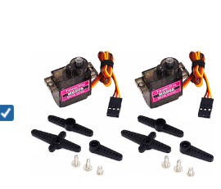
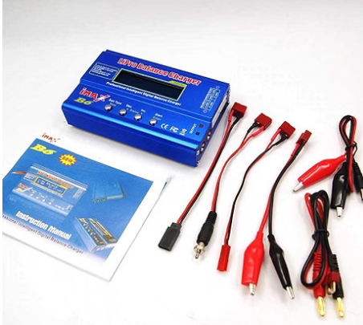
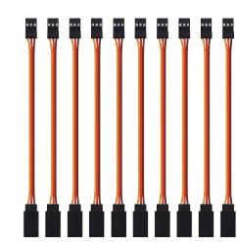

MG90S Metal Gear Micro Servo Motor
Lipo battery imax charger
Servo Extension cables (30cm)
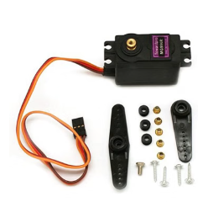
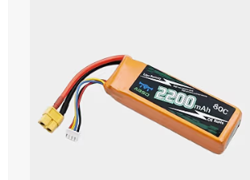
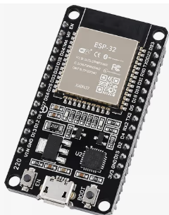

ESP32 Development Board
Lipo 2200mah battery
MG996R Metal Gear Servo Motor
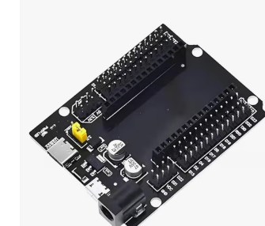
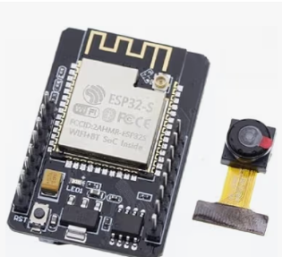
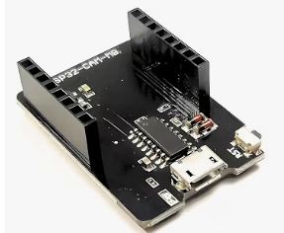

ESP32 Cam Module
ESP32 GPIO Extension board
ESP32 Cam Module Extension board
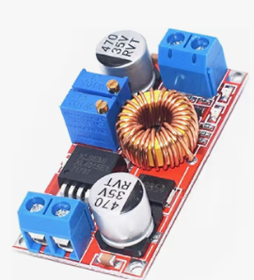
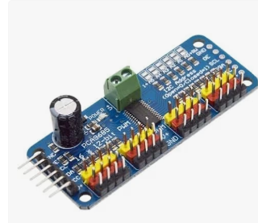
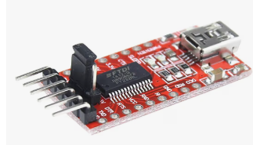

FTDI Programmer (USB-to-TTL)
XL4015 5A Buck Converter
PCA9685 16-Channel Servo Driver

Specifications to Look For on the Battery Label
When browsing the options in your college lab, pick a pack that matches these specs:
- Cell Count: 3S or 11.1V
- Capacity: 2200mAh to 3300mAh (provides 30–45 minutes of active movement testing)

Power Supply & Voltage Regulation Wiring
From Source | Pin / Terminal | To Destination | Pin / Terminal | Purpose
3S LiPo Battery | Red Wire (+) | XL4015 Buck Converter | IN+ | Raw 11.1V Battery Input
3S LiPo Battery | Black Wire (-) | XL4015 Buck Converter | IN- | Battery Ground
XL4015 Output | OUT+ (Set to 6.0V) | PCA9685 Driver | Green Screw Terminal V+ | Servo Power Rail
XL4015 Output | OUT- (GND) | PCA9685 Driver | Green Screw Terminal GND | Motor Ground
XL4015 Output | OUT+ (Set to 6.0V) | ESP32 Expansion Board | VIN (or 5V) | Board Main Power
XL4015 Output | OUT- (GND) | ESP32 Expansion Board | GND | Shared System Ground

Control & I2C Signal Wiring (ESP32 to PCA9685)
From Source (ESP32 Expansion Board) | Pin / Terminal | To Destination (PCA9685 Driver) | Pin / Terminal | Purpose
ESP32 Expansion Board | 3.3V | PCA9685 Driver | VCC | Logic Power for Driver IC
ESP32 Expansion Board | GND | PCA9685 Driver | GND | Shared Signal Ground
ESP32 Expansion Board | GPIO 21 | PCA9685 Driver | SDA | I2C Data Line
ESP32 Expansion Board | GPIO 22 | PCA9685 Driver | SCL | I2C Clock Line

PCA9685 Updated Driver Output Wiring
PCA9685 Channel | Wire Alignment | Connected Servo | Joint Control
Channel 0 | Yellow/Orange (PWM), Red (V+), Brown/Black (GND) | MG996R | Base Rotation
Channel 1 | Yellow/Orange (PWM), Red (V+), Brown/Black (GND) | MG996R | Shoulder Lift
Channel 2 | Yellow/Orange (PWM), Red (V+), Brown/Black (GND) | MG996R | Elbow Movement
Channel 3 | Yellow/Orange (PWM), Red (V+), Brown/Black (GND) | MG90S | Wrist Pitch
Channel 4 | Yellow/Orange (PWM), Red (V+), Brown/Black (GND) | MG90S | Gripper Actuation
Channel 5 | Yellow/Orange (PWM), Red (V+), Brown/Black (GND) | MG90S | Camera Mount / Spare Joint

